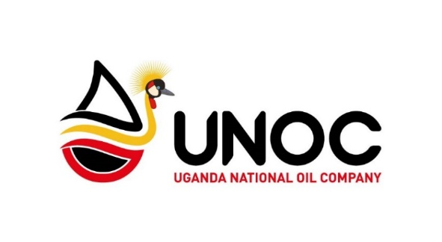
UGANDA REFINERY HOLDING COMPANY LTD
Headquarters at Amber House, P.O Box 36316, Kampala

THE UGANDA REFINERY HOLDING COMPANY (URHC) IS RECRUITING

The Uganda Refinery Holding Company (URHC) is a Private Limited Liability Company that was incorporated under the Companies Act (2012) as a subsidiary of the Uganda National Oil Company (UNOC). The objective of the URHC is to hold Government’s interest on behalf of UNOC in the oil refinery and associated infrastructure. URHC, in partnership with an investor partner, will design, develop, build, operate and maintain the Uganda Refinery Project to be located in Kabaale, Hoima District. URHC has also been given the mandate to develop, operationalize and manage the 29.57 km² Kabaale petro-based Industrial Park (KIP). The Refinery and Uganda’s second International Airport will form the industrial park’s anchor projects.
URHC now invites applications for persons interested to develop their career with a dynamic results-oriented Company to occupy the following position:

JOB TITLE: MANAGER, KABAALE INDUSTRIAL PARK DEVELOPMENT (1 POSITION)
REPORTS TO: GENERAL MANAGER, UGANDA REFINERY HOLDING COMPANY LTD.
JOB PURPOSE:
- Implement the strategic plan for the development, operationalization and management of KIP in line with UNOC’s overall Mission and Vision.
- Provide planning and coordination management to the KIP project team members and all key stakeholders to facilitate effective implementation of the Detailed Master Program in accordance with the KIP Program Roadmap.
- Identify, evaluate and eventually work with an experienced joint venture partner for the development, operationalization and management of the Kabaale petro-based Industrial Park.

SPECIFIC DUTIES AND RESPONSIBILITIES
- Develop a program roadmap and workplans for the development, operationalization and management of the Kabaale petro-based Industrial Park (KIP).
- Coordinate and manage the industrial park project activities.
- Participate in the industrial park development activities including, inter alia, benchmarking, investor promotion, lease allocations, physical planning, infrastructure development (including intra-park road network, power, water, wastewater treatment, and ICT), design and construction.
- Identify and propose bankable projects and establish goals, objectives, strategies and budget requirements for developing new business.
- Prepare and implement a risk management framework for KIP project activities.
- Develop proposals for sourcing the equity and debt financing for KIP project activities.
- Develop and implement the QHSE strategy for the KIP project area.
- Assist KIP leaseholders with all Government of Uganda consent requirements, including permit, approval and license requirements, to include, inter alia, Environmental Social Impact Assessments.
- Monitor and report on construction activities within the KIP project area to ensure that projects are completed per design deliverables, quality standards and that pre-start up safety reviews are conducted.
- Develop and implement a security monitoring and enforcement strategy within the Industrial Park.
- Supervise, appraise and develop the project management team.
- Perform any other duties as may be reasonably assigned within the scope of the Job role.
QUALIFICATIONS
- A Master’s degree in planning, or public policy, or development studies, or strategic planning, or Business Administration or other relevant Master’s degree.
- An honours Bachelor’s degree in Mechanical, Chemical or Civil Engineering, Applied Science or other relevant Bachelor’s degree.
- A post graduate qualification in project management would be an added advantage.
EXPERIENCE
- At least 10+ years' work experience in strategic planning and management or project planning and implementation.
- Demonstrated experience in working with government partners and other stakeholders in public sector development programs.
- Experience in in the Oil and Gas Industry would be an added advantage.
- Verifiable knowledge of working in an industrial park would be an added advantage.
SKILLS AND COMPETENCIES
- A self-starter with ability to work with minimal supervision with strong organizational skills
- High level written and oral communications skills
- Must be results-oriented, a team player, exhibiting high levels of enthusiasm, tact, diplomacy and integrity
- Demonstrate excellent interpersonal and professional skills in interacting with investors, government and development partners
- Experience in research, strategic theme development, project management and programming-related work
- Team leadership skills
- Quality orientation/attention to detail skills
- Risk Management skills
- Negotiation skills.
- Competency with MS Office required. Knowledge of project planning software would be an additional advantage.
Application procedure:
Electronically completed and signed Applications Forms together with certified copies of academic certificates should be addressed and submitted in TRIPLICATE to the address below by 17:00 hours (5:00pm EAT) not later than Friday, 29th June, 2018. Applications delivered through registered mail and courier will also be received. Applications must include a cover letter, application form and supporting documents.

While we thank you for your interest, only shortlisted candidates will be contacted. Any form of lobbying will lead to automatic disqualification.

The Job Application Form can be downloaded from Resources > Jobs and Tenders on www.unoc.co.ug

GENERAL MANAGER
UGANDA REFINERY HOLDING COMPANY LTD
P.O.BOX 36316
KAMPALA
4TH FLOOR AMBER HOUSE, PLOT 29/33 KAMPALA ROAD.
ROOM C406

